Part 1

1. Run a query to view the information within the Customers table.

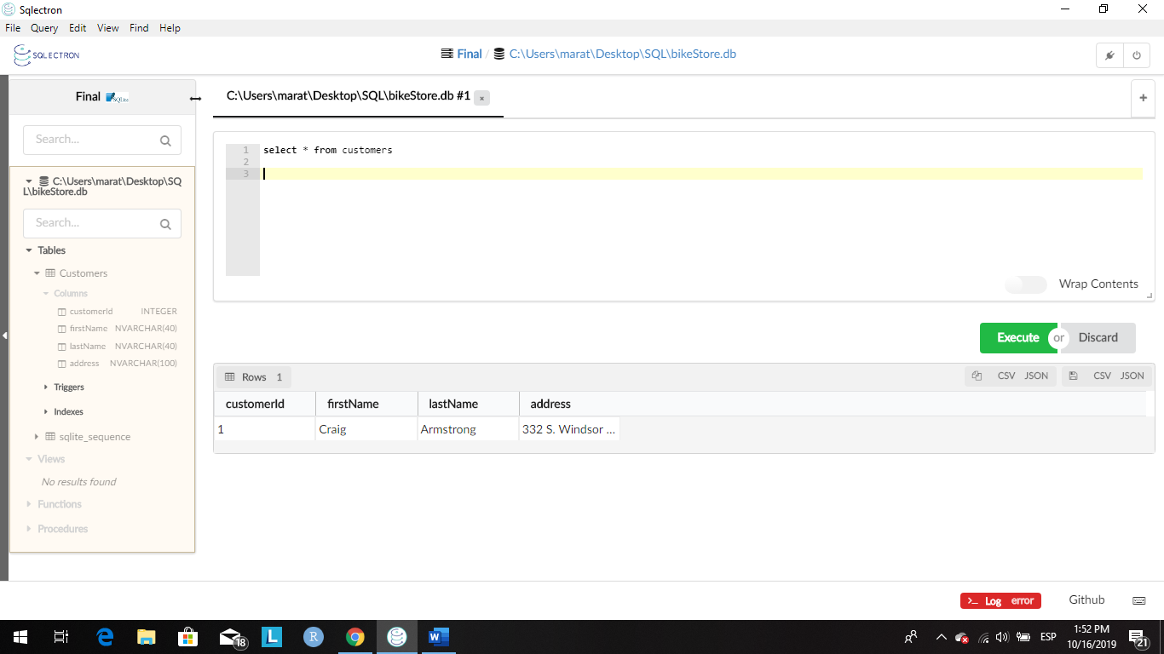

1. Write out the query that would have been used to create the Customers table

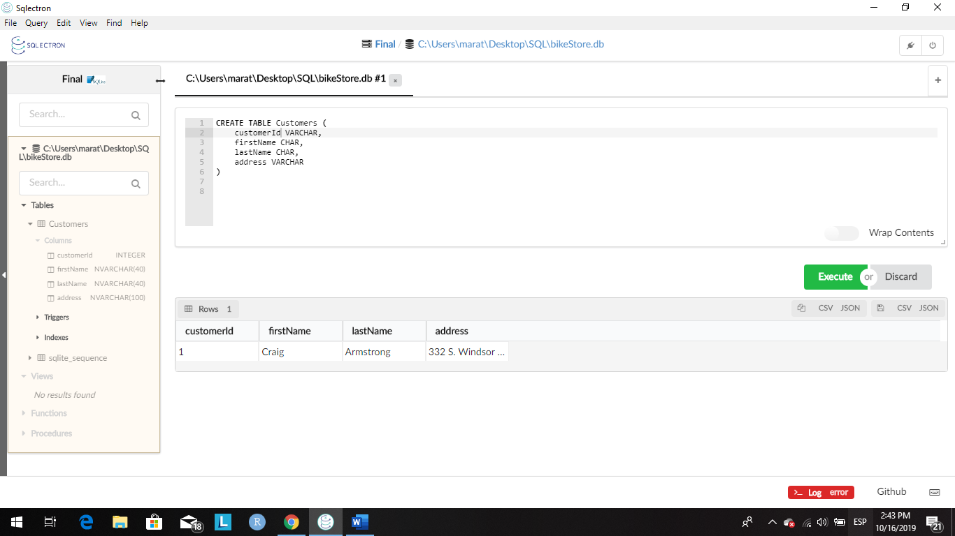

1. Currently, there is only one customer within the Customers table. Add the following customers:

|  |  |
| --- | --- |
| **Name** | **Address** |
| **Kenneth Davis** | 84 E. Heathcoat Rd. Avon, CT. 06001 |
| **David Shirley** | 3493 N. Star Way Eagle, ID. 83669 |
| **Donna Bumbleton** | 255 E. Main St. P.O. Box 38 Louisville, KY 40018 |

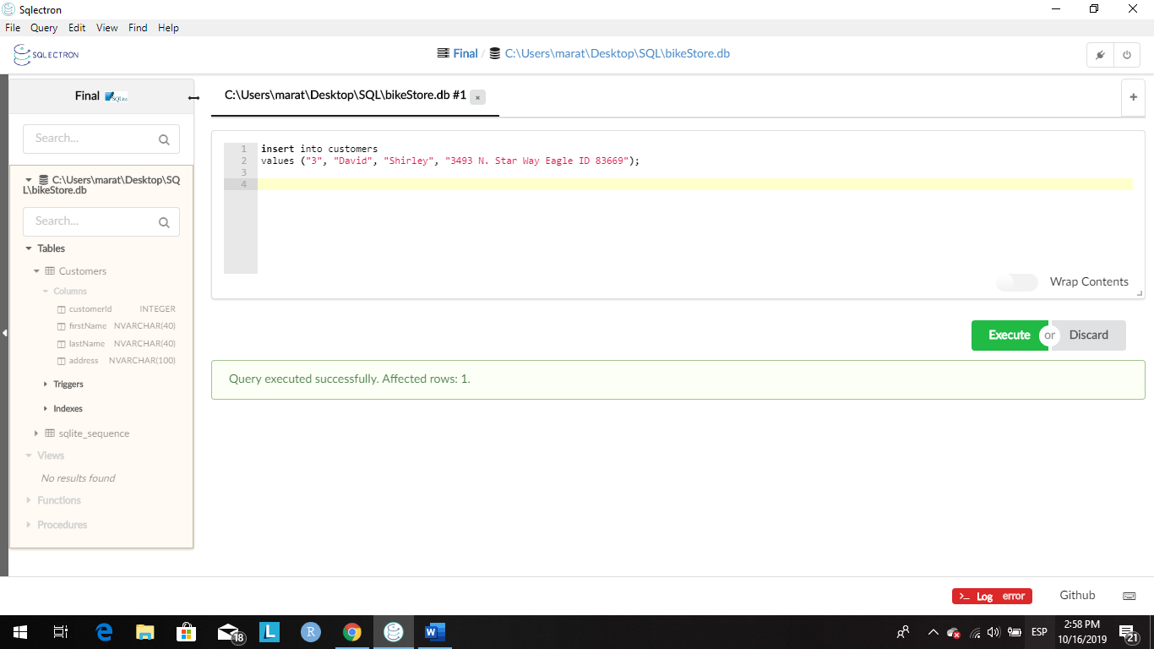

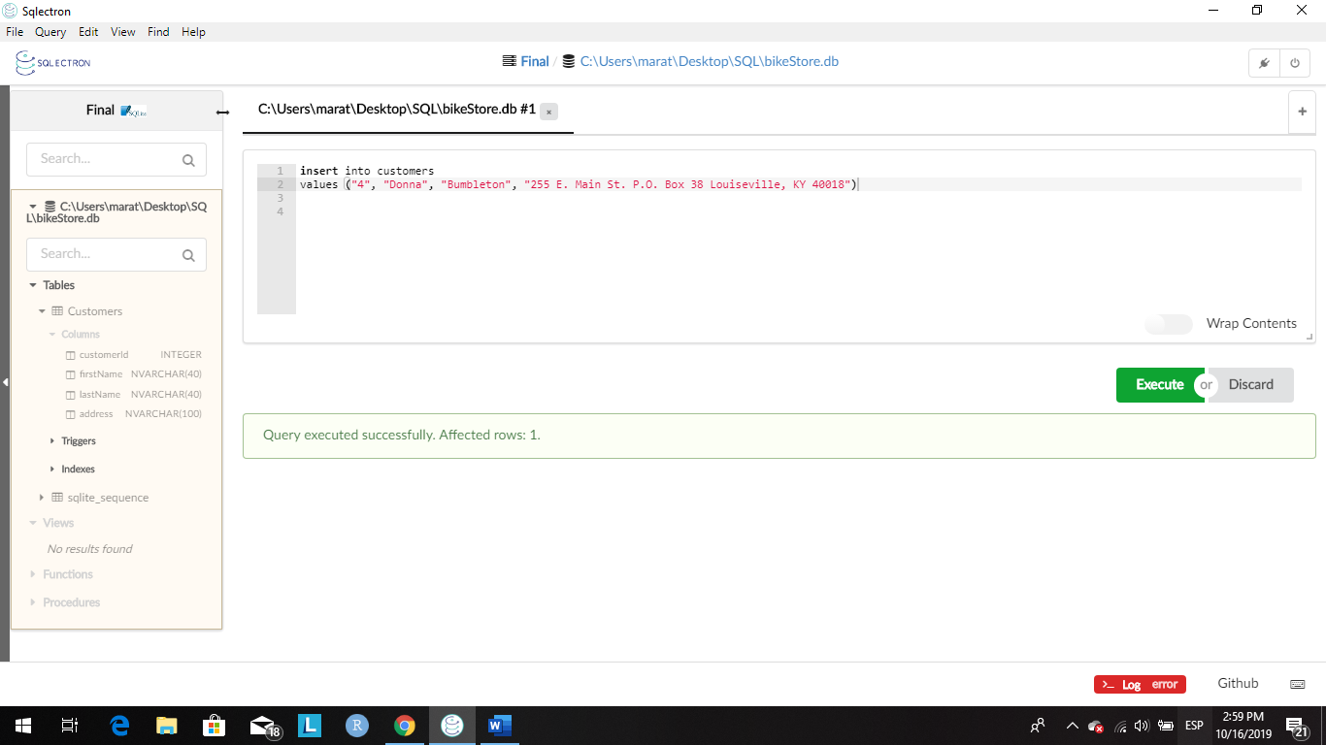

1. Run a query to see all of the new customers within the database.

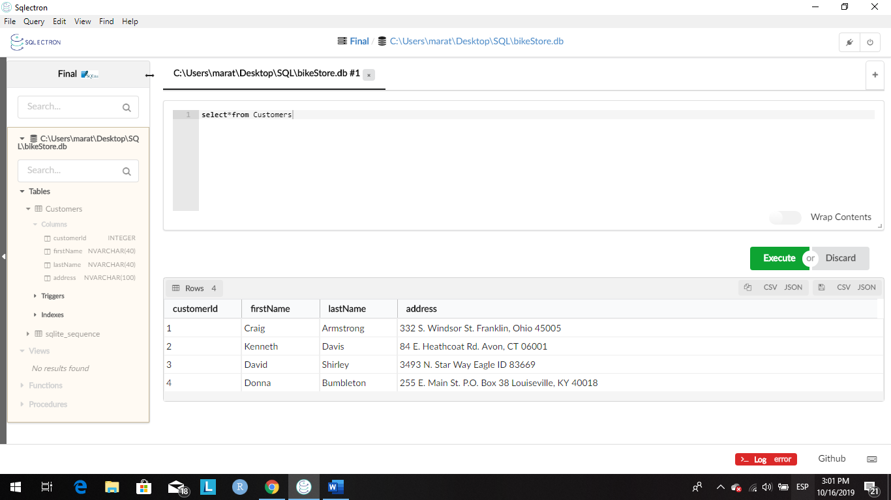

Part 2

1. Run the following SQL query to add a new table into the database:

CREATE TABLE Products(

productId INTEGER PRIMARY KEY AUTOINCREMENT,

brand NVARCHAR(50) NOT NULL,

type NVARCHAR(50) NOT NULL,

model NVARCHAR(50) NOT NULL,

yearProduced INTEGER,

instock INTEGER CHECK(instock IN (0, 1))

)

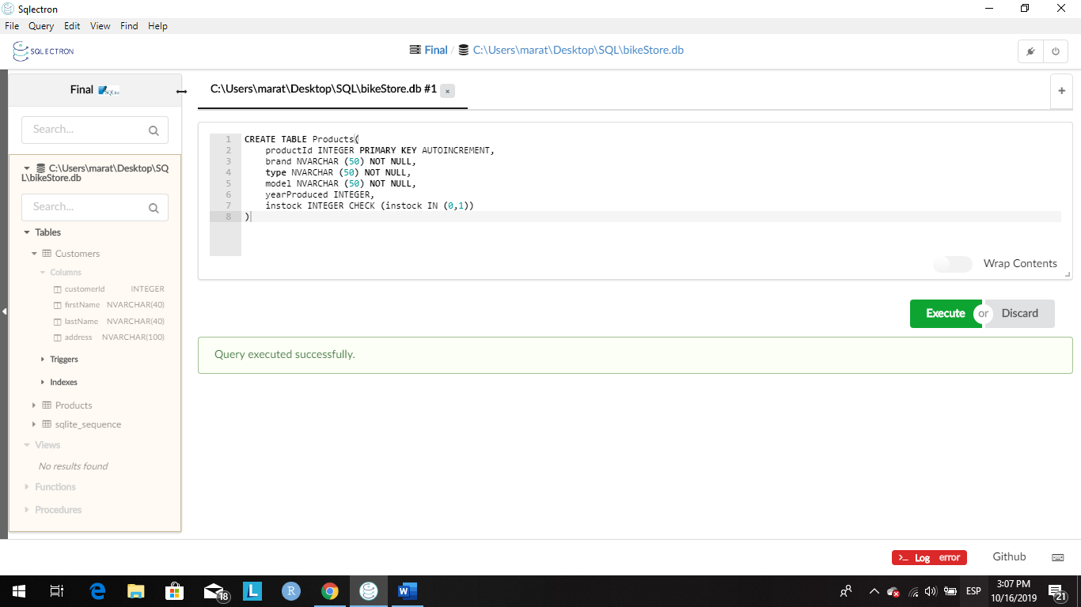

1. Next, run the following insert statements to add some data to the Products table:

-- query 1

INSERT INTO Products (brand, type, model, yearProduced, instock)

VALUES ("Specialized", "Road", "Langster Street", 2018, 1)

-- query 2

INSERT INTO Products (brand, type, model, yearProduced, instock)

VALUES ("Trek", "Mountain", "820 WSD", 2019, 1)

-- query 3

INSERT INTO Products (brand, type, model, yearProduced, instock)

VALUES ("Specialized", "Triathlon", "Alias Comp Tri", 2015, 0)

-- query 4

INSERT INTO Products (brand, type, model, yearProduced, instock)

VALUES ("Electra", "Single Speed", "Loft 1", 2015, 1)

1. Run a query to see all of your products.

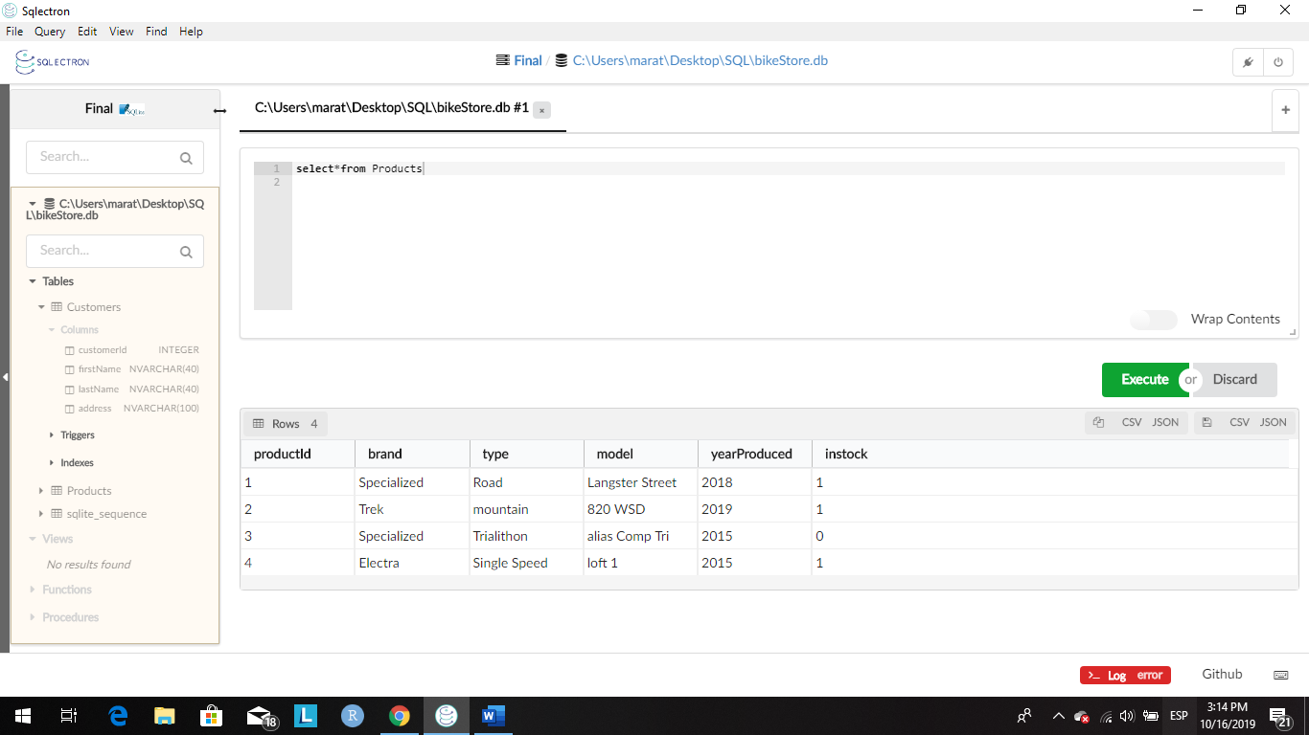

Part 3

1. Run the following SQL query to add a new table into the database:

CREATE TABLE Orders(

orderId INTEGER PRIMARY KEY AUTOINCREMENT,

customerId INTEGER NOT NULL,

productId INTEGER NOT NULL,

FOREIGN KEY(customerId) REFERENCES Customers(customerId),

FOREIGN KEY(productId) REFERENCES Products(productId)

)

First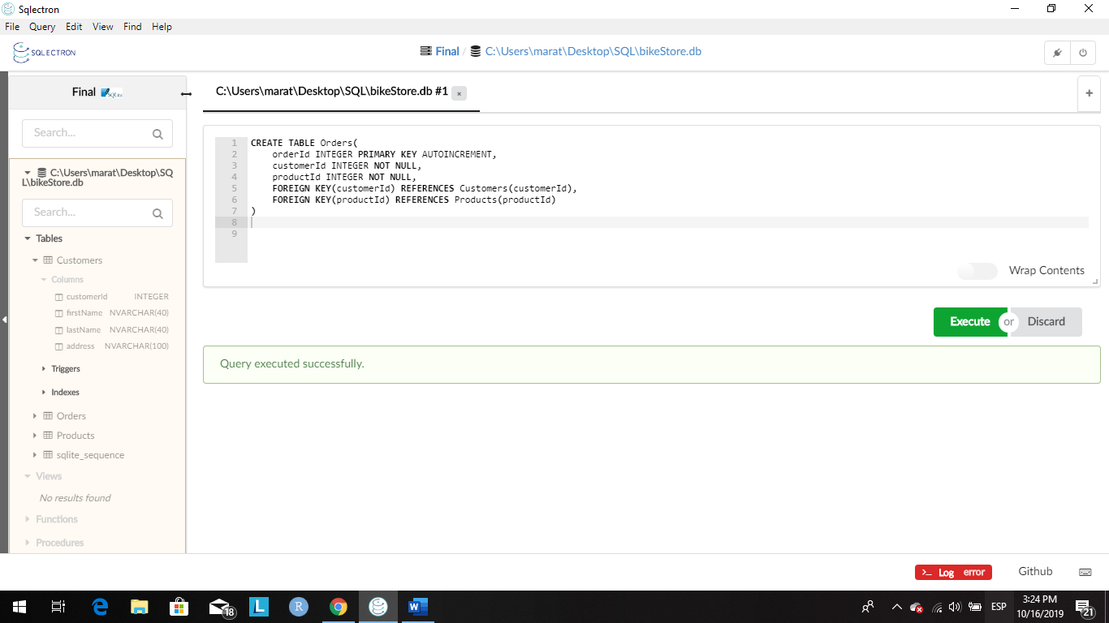

1. Next, run the following insert statements to add some data to the Orders table:

-- query 1

INSERT INTO Orders (customerId, productId)

VALUES (1, 2)

-- query 2

INSERT INTO Orders (customerId, productId)

VALUES (2, 1)

-- query 3

INSERT INTO Orders (customerId, productId)

VALUES (3, 2)

-- query 4

INSERT INTO Orders (customerId, productId)

VALUES (4, 1)

1. Lastly, run a query to see the customer's full name, their address, and their orderId as well as the brand, type, model, and yearProduced of the bicycle they ordered. The list of customers should be ordered in alphabetical order by their last name.

